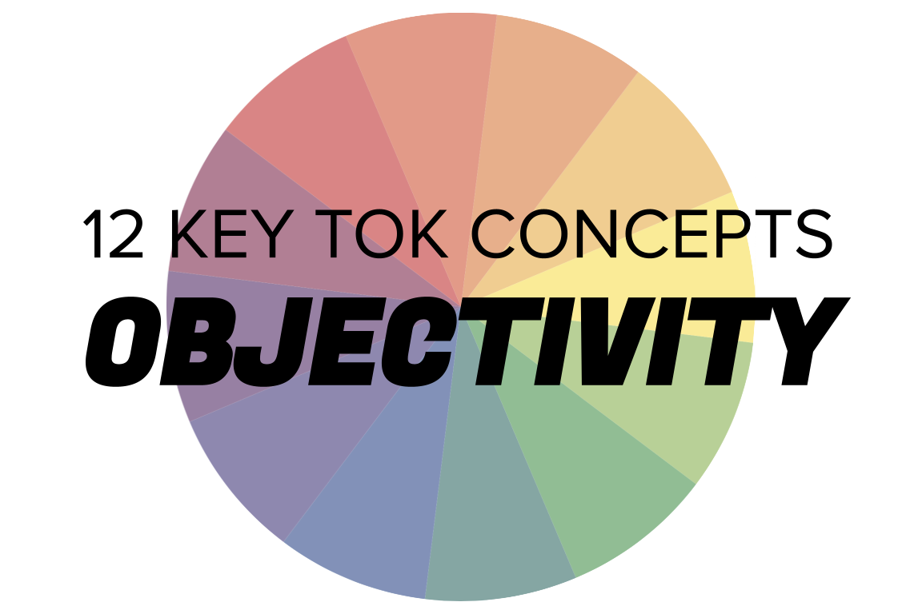 | OBJECTIVITY

Understanding the 12 key concepts
- The 12 key concepts are ones that have been identified as having a particular significant relationship to knowledge.
- Understanding, exploring, and using these concepts will help you to understand the way knowledge is produced and used, within the core and optional themes, and the areas of knowledge.
- You should also try to use the key concepts as extensively as possible in the two TOK assessment tasks.
Starting points for objectivity  - How many online definitions can you find for ‘objectivity’?  - Which one do you think best sums up this concept, and why?  - Which of the quotes do you think provides us with the best insight into objectivity? Are there any you disagree with?  - How objective do you think you are - and what gets in the way of your ability to be objective? | Quotes on objectivity  - After all, the ultimate goal of all research is not objectivity, but truth. Helene Deutsch  - Dispassionate objectivity is itself a passion, for the real and for the truth. Abraham Maslow  - Objectivity is the subject subjugating the object. That is how you assert yourself. You make yourself the active voice and the object is the passive no-voice. Emily Levine  - Science is based on the possibility of objectivity, on the possibility of different people checking out for themselves the observations made by others. Without that possibility, there is no empirical principle capable of deciding between different arguments and theories. Jose Padilha  - To increase our objectivity, we must learn to switch off the mini-movies. Objectivity requires us to be mindful, present in the moment, and experiencing what is happening without judgment. Elizabeth Thornton  - I think objectivity is like this strange myth that people think you're supposed to achieve, but actually, the dirty little secret is that it's not attainable any more than pure justice is attainable by the courts. Sebastian Junger
Interlinking the key concepts  - Is objectivity the prerequisite of certainty?  - Can values be arrived at objectively?  - How do we balance the need to accept different perspectives with the need to be objective?  - Do cultural differences hinder our ability to approach knowledge with objectivity?  - Does power undermine our ability to be objective? | Relating objectivity to the TOK course  - Which of the areas of knowledge deal with the most/least objective evidence?  - Is mathematical knowledge completely objective?  - Can we be objective about the arts?  - Has technology allowed us to produce knowledge more objectively?  - Do our political and religious affiliations always undermine our ability to be objective?
Relating objectivity to the TOK exhibition  - IAP-12: Think about the extent to which we can remain objective, and resist producing knowledge according to our biases  - IAP-20: Think about the effect of our own personal experiences on our ability to remain objective  - IAP-23: Think about whether material tools can help us produce or acquire knowledge in an objective way  - IAP-28: Think about how we can produce or acquire knowledge in an objective manner | Relating objectivity to the Big Questions  - BQ1 - How do we approach knowledge objectively?  - BQ2 - Is there a moral responsibility to be as objective as possible?  - BQ3 - How do we communicate knowledge objectively?  - BQ4 - Do our perspectives always undermine our ability to approach knowledge objectively?  - BQ5 - How has our ability to be objective about knowledge changed over time?  - BQ6 - Is being objective the key characteristic of an expert knower?

Real-world contexts for objectivity

The media sources below explicitly mention certainty, and discuss this key concept in a real-world context. Use the find command (ie Command/Control+F) to locate the term in the article or transcript of the video, and you’ll see where it features. Check back regularly, as we update these media sources every month.
Big Question / knowledge framework | Description of media source and story and links to the course
BQ1 / Nature & scope | A New Humanist review of the book Time’s Monster, which argues that the modern historian should be a “critic of government”. History, Politics, Human sciences  An Aeon article exploring how in order to understand sense perception more, we should consider the way in which smell (rather than vision) works. Knowledge & the knower, human sciences  A Big Think article, in which Donald Hoffman argues we have evolved to experience a “collective delusion”. Knowledge & the knower, human sciences
BQ2 / Values | A Big Think article, which argues that Russia’s crimes in Ukraine signifies that morality is objective rather than subjective. Human sciences, History, Politics  An Aeon essay, considering the extent to which we should rely on empathy to achieve objectivity. Knowledge & the knower, Human sciences  A Verge article that looks at whether it is possible to answer moral questions by consulting an online AI bot called Delphi. Technology, Human sciences, Language
BQ3 / Methods & tools | A New Statesman article, arguing that story-telling is essential to making statistics meaningful in the human sciences. Human sciences, Mathematics, Technology  A Smithsonian article, which explores how whilst the technology of deep fake videos is new, the intention to mislead viewers has always driven image-makers. Technology, The arts, Politics  This Big Think article deconstructs how maps are used to show the migration of people, and how their language and designs are often loaded with meaning. Human sciences, language, knowledge & the knower, politics
BQ4 / Perspectives | A Conversation article, analyzing how people from both sides of the political spectrum only detect bias when it supports the opposing party. Politics, Knowledge & the knower, Human sciences  A Salon article, arguing that the term ‘feminist science’ is not an oxymoron, and offers a powerful set of tools for examining knowledge. Natural sciences, Knowledge & the knower, Politics  A Guardian story about the only foreign journalist embedded with Russian forces as they invade Ukraine. Human sciences, Politics, History  A short History Today article, looking at EH Carr’s famous assertion that historians “fish for the truth”. History, Language  A Vox interview with Jane Goodall, in which she discusses, amongst other things, the need to ditch the idea of human exceptionalism. Natural sciences, Human sciences  A Wired article, considering how our bias against ugly flora and fauna leads to gaps in our scientific knowledge. Natural sciences, human sciences  This Guardian video looks at the people around the world who genuinely believe that the earth is flat. Rather than passing judgement, it attempts to understand why they hold this belief. Knowledge & the knower, natural sciences  An Aeon essay, looking at the extent to which we can apply ‘laws’ similar to the ones in science to our study of the past. History, natural sciences
BQ5 / Methods & tools | A Vox article, which considers how the Nobel Prize has a negative impact on the production of new scientific knowledge. Natural sciences, Human sciences  A Boston Review article, looking at the rise and fall - and rise again - of epistemology is linked to the way digital media has taken over society. Human sciences, technology, politics  An extensive Guardian article that considers how figuring out the patterns and cycles of history could help us understand both the past and the present more effectively. History, human sciences, natural sciences  A Smithsonian article looking at the effect of World War I on the way we understand psychology. Human sciences, language, knowledge & the knower, history
BQ6 / Methods & tools | A BBC article looking at how experts disagree over whether one of Ed Sheeran’s songs was plagiarized. The arts  A Guardian article, looking at a military and academic project to predict the beginning of the next war via an exploration of novels. The arts, history, human sciences, politics  A Now and Then video, looking at the extent to which we can - and should - apply objectivity to our study of the past. History, the arts, language  This is a New Statesman article by the great-grand-daughter of EH Carr, one of the most influential historians of the last 20th century. It discusses his approach to this area of knowledge, and what he believed the purpose of history - and the historian - was. History, knowledge & the knower  This is a Guardian video that looks at the people around the world who genuinely believe that the earth is flat. Rather than passing judgement, it attempts to understand why they hold this belief. Natural sciences, human sciences, knowledge & the knower

